OrgPublisher Basic Input File Layout

Table of Contents
Basic Input File Layout 3
Sample CSV File 3
Input File Layout Table 4

Basic Input File Layout
The Input File Layout defines the order of columns in the comma-separated test file that OrgPublisher opens to generate your org chart. The Basic, along with the Advanced version of the file layout, is used in OrgPublisher as one of the official data formats for OrgPublisher Prebuilt Reports.
Each record in an OrgPublisher input file typically represents a manager, an employee, an open position, an assistant, a partner, or a contractor in the org chart. In addition, an input record can represent a normal box, assistant box, or a partner box within the hierarchy of boxes in the chart.

Sample CSV File
You can use the sample CSV file to preview what a File Layout looks like, and even try it out by importing it into the New Chart Wizard. Select Edit mode to open the embedded spreadsheets in this document.

Basic Input File Layout Table
The first two fields are required to build a reporting structure. These fields can include information from your HR database, such as a supervisor ID and an employee ID, or a supervisory department and reporting department. Each person or position in an org chart is represented by only one record in the Input File.
The color coded legend in the upper left corner helps you identify where your data should be mapped within the 40 supplied fields.
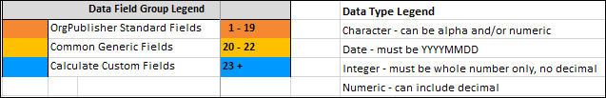

Note: There should be no special characters (such as #, -, |, :, ", /, \, ?, *, %, +, =, <, >, @, $, &, etc.) in field names.

