2012 Economic Census Statistics

Gasoline Stations NAICS 447

Washington
http://thedataweb.rm.census.gov/TheDataWeb_HotReport2/econsnapshot/2012/snapshot.hrml?STATE=49&COUNTY=ALL&x=30&y=6&IND=%3DCOMP%28C2%2FC3*1000%29&NAICS=447

2012 Sales per capita ($)

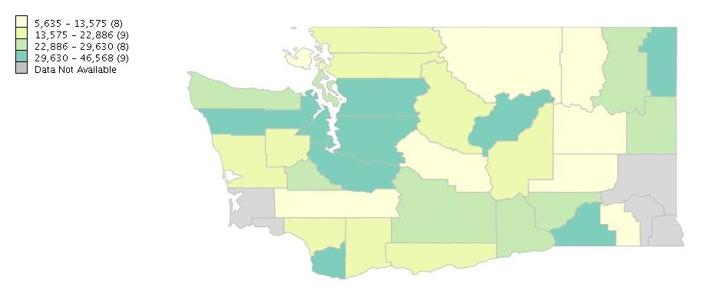

California
http://thedataweb.rm.census.gov/TheDataWeb_HotReport2/econsnapshot/2012/snapshot.hrml?STATE=6&COUNTY=ALL&x=45&y=1&IND=%3DCOMP%28C2%2FC3*1000%29&NAICS=447

2012 Sales per capita ($)
